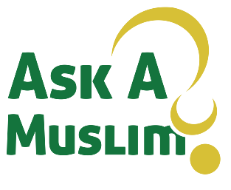
New Muslim Form

Name of Da’ee____________________

1. Name: _____________________________________________________
2. Ph #:_______________________________________________________
3. Masjid Near You:______________________________________________
4.Working? Yes No
5. Email Address:_______________________________________________
6. Brother/Sister Brother Sister
7. Date Of Reversion:____________________________________________
8.Own Transportation: Yes No
***VERY IMPORTANT***
CAREFULLY FOLLOW INSTRUCTIONS TO REGISTER ALL NEW MUSLIMS FOR UPDATES AND EVENTS SPECIFICALLY DONE FOR NEW MUSLIMS!

1. CREATE TEXT MESSAGE

